Part 1.

1. The equations for log transformation:

s = c * log(1 + r), where: c is a constant and r is the intensity of a pixel.

The effect of log transformation is to stretch low intensity values and compress high intensity values.

The equations for power-law transformation:

s = c * rg , where: c is a constant, r is the intensity of a pixel, and g is a parameter controlling the power calculation.

The effect of power-law transformation is to enrich the functionality of log transformations. By defining different g values, different parts in the grey level can be stretched or compressed.

The image before transformation:

The images with different r transformation:

|  |  |
| --- | --- |
|  |  |
| r = 0.3 | r = 3 |

When a power law transformation with r = 0.3 is applied, the intensity levels tend to grow larger toward 1 under the effect of 0.3 power, which results in a brighter image. When r = 3 is applied, intensity levels shrink toward 0, so they just get darker.

2. Images of bits slicing:

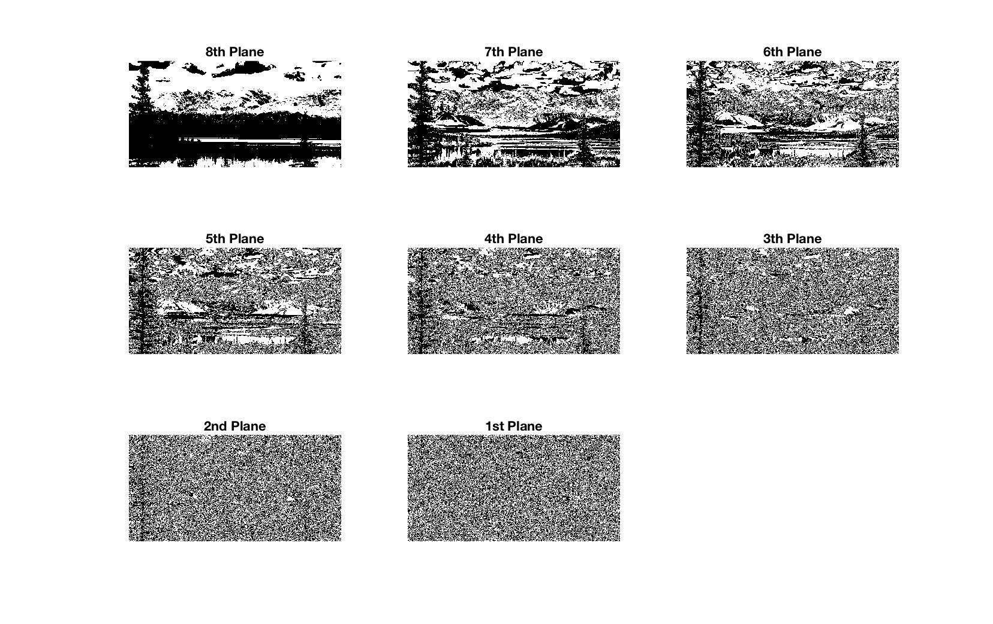

The reconstructed image from the highest 4 big planes:

3.